# Laboratory work №6 Basic control action in dynamic systems

## Objective

To get acquainted with the principles of synthesis of control systems for technical systems in the Simulink software environment.

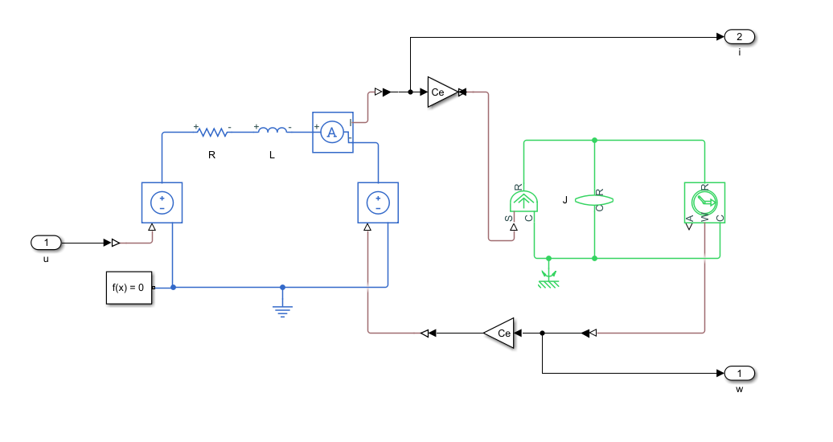

Figure 1. Simulation scheme of the electromechanical system DC motor – mechanical load.

## The lab work task

1. Create a model of electromechanical system DC motor – mechanical load in Simulink. The parameters are set by the teacher.
2. Calculate the transfer function of the control object from the control signal to the controlled coordinate (speed).
3. Calculate coefficients for P-controller, PI-controller and PID-controller by Ziegler Nichols method.
4. Simulate the synthesized control system with following reference signals:
5. g(t) = 1 rad/s;
6. g(t) = 0.1∙t.
7. Determine the quality indicators of control systems for each regulator:

a. Overshoot.

b. Transition time.

c. Steady-state error.

d. Fluctuation index.

## Report content

1. Calculation of the transfer function of the control object.

2. Synthesis of the control system.

3. Graphs of frequency characteristics and transients.

4. Calculation of quality criteria.

5. Conclusions.